**Enabling More Targeted Promotions and Lower Customer Acquisition Costs using Data Engineering and AI**

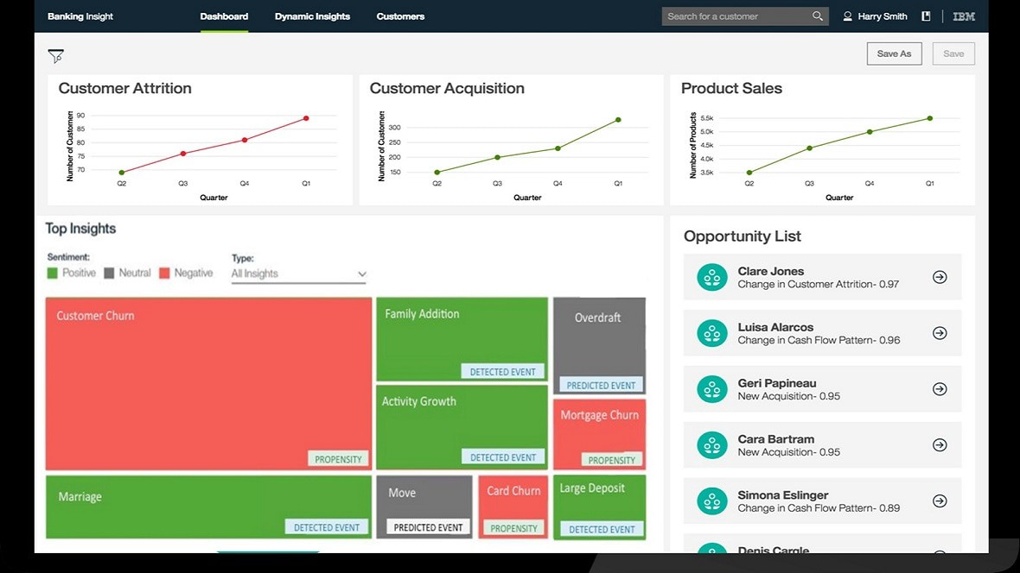

Improving the marketing campaigns of BFSI to boost conversion rates while lowering customer acquisition costs. To better target clients and promote the most appropriate products and services, and identify channels, offers, and approaches.

Banks and financial services providers are challenged to meet and exceed customer expectations in today’s connected and digital world. Financial institutions must focus on engaging with their customers to remain competitive and relevant. Data science solutions help financial institutions achieve digital transformation and redefine customer relationships. Customer insights provide deep knowledge about customers to optimize each interaction with the customer.

Customers tend to respond faster to personalized and real-time services -which is an important factor that gives a differentiating advantage to banks that have adopted Data and AI-driven capabilities from traditional vendors, which tend to accommodate better individual preferences or even leverage on financial intermediaries that hold a high degree of customer trust and understanding. Part of what’s attracting consumers to such players is their ability to customize offers for certain segments of the active customer base.

**The level of data science adoption in the banking industry remains low**

*Banks are facing numerous challenges in sustaining profitability due to changing customer behaviors, strong competition, tighter regulations, and digital discrepancies*

**Adoption of a New Banking Model in the era of Artificial Intelligence**

According to a survey performed**by Wipro** on why Artificial Intelligence is the future of banking as it brings the power of advanced data analytics to customer experience, fraud management, and operations. AI algorithm accomplishes anti-money laundering activities in a few seconds, which otherwise take hours and days. AI also enables banks to manage huge volumes of data at record speed to derive valuable insights from it. Features such as AI bots, digital payment advisers, and biometric fraud detection mechanisms lead to a higher quality of services to a wider customer base. All this translates to increased revenue, reduced costs, and a boost in profits.

AI is strengthening the competitiveness of banks in the customer personalization domain through:

**Enhanced customer experience:** Based on past interactions, AI better understands customers and their behavior. This enables banks to customize financial products and services by adding personalized features and intuitive interactions to deliver meaningful customer engagement and build strong relationships with their customers.

**Prediction of customer behavior and response:** With its power to predict future scenarios by analyzing past behaviors, AI helps banks predict future outcomes and trends. This helps banks to identify fraud, detect anti-money laundering patterns and make customer recommendations. Similarly, AI can detect suspicious data patterns among humungous volumes of data to carry out fraud management. Further, with its key recommendation engines, AI studies the past to predict the future behavior of data points, which helps banks to successfully up-sell and cross-sell.

**Effective decision-making**: Cognitive systems that think and respond like human experts, provide optimal solutions based on available data in real-time. These systems keep a repository of expert information in their database called a knowledge database. Bankers use these cognitive systems to make strategic decisions.

**AI technologies unleash the power of data in banking**

Traditional financial services business models are under the microscope. For many financial organizations, sustained profitability is a challenge in today’s lower-interest-rate environment. Competition from new market entrants is also generating new layers of disruption, while customer experience and engagement are not keeping pace with the ever-growing expectations of digitally-savvy consumers.

Many financial organizations have responded with headcount reductions and tactical cost-cutting measures. However, sustainable performance requires a shift in strategy — a strategy enhanced by new technologies.

Success in the digital age requires banks to tap the hidden treasure they already own in massive quantities: data. Cognitive systems and AI technologies can help banks unleash the power of their data, revealing insights about the enterprise, customers, and competitors. Cognitive systems continually build knowledge and learning, understand natural language, and reason and interact more naturally with human beings than traditional programmable systems.

**Customer 360: Understanding the Customer DNA**

Having a 360-degree view of all facets of a customer’s activity and engagement with the bank would enable a holistic approach. The figure below provides some of the key data domains that should be incorporated.

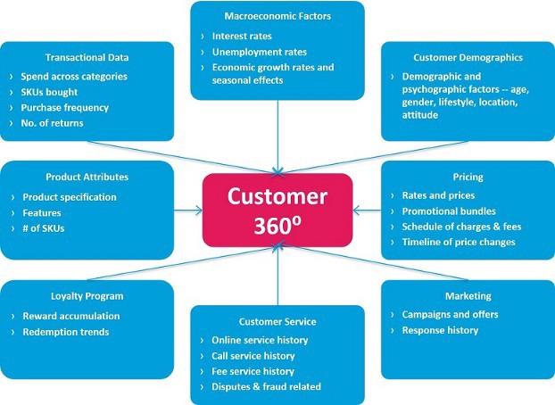

Datamart to build a 360 Customer Analytics View Source: Shamli Prakash

Building this customer 360 data mart in a scalable, phased manner is the foundation for many customer analytics use cases such as propensity modeling, cross-sell/upsell recommendation, customer lifetime value, etc. The customer 360 approach incorporates the spectrum of customer data domains ranging from demographic info, transactional data, product ownership, customer interaction, customer service, campaign response, pricing, and macroeconomic data.

Feature engineering is the process of using domain knowledge of the data to create features that make machine learning algorithms work. It plays a pivotal role in defining and creating data elements that capture customer behavior. To this end, additional features are created as a combination of these data domains (e.g. rolling month averages, dummy variables, etc.)

**IBM Roadmap to Data & AI - The Customer Analytics Ladder**

Banks realize that one of the key steps to being competitive in today’s market is to raise engagement through high-quality, personalized relationships with their customers.

The idea is to analyze client experience and personalize it taking into account the client’s interests and preferences. AI is making significant improvements in understanding customer behavior patterns, which brings customer personalization to a whole new level.

Data scientists can also build models that study the client’s behavior and discover situations where customers needed financial advice. The combination of predictive analytic tools and advanced digital delivery options can help with this complicated task, guiding the customer to the best financial solution at the most opportune time and suggesting personalize offerings based on spending habits, social-demographic trends, and relevant needs and other preferences.

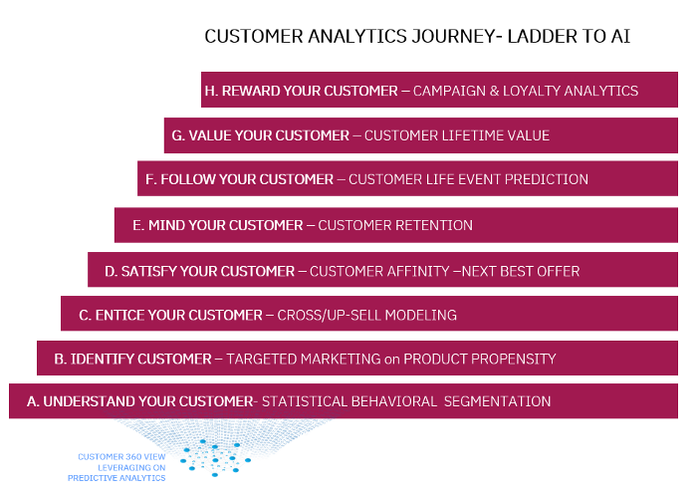

Customer Analytics Journey-Personalization Strategies

In the section below a structured customer, interaction journey is outlined across the maturity lifecycle leveraging data analytics starting with the foundations of understanding the customer behavior using dynamic segmentation techniques to following the customer across the lifecycle journey and rewarding him with personalized campaigns and promotions.

**a. Understand your customer: Behavioral Segmentation**

Customer segmentation is the process of dividing customers into groups based on common characteristics so companies can market to each group effectively and appropriately. There are different variations of segmentation (e.g. behavioral segmentation) or specific characteristics (e.g. demographic).  
Customer segmentation is designed to improve customer service and help in loyalty and retention of customers, which is so necessary for the banking sector.

Segmentation allows marketers to customize their marketing efforts to target customers by understanding homogeneous characteristics. Those efforts can relate to both communications and product development. Specifically, segmentation helps a retail bank:

1. Customer profiling so that we can focus on the most high-value, active, and digital-savvy customers.
2. Create and communicate targeted marketing messages that will resonate with specific groups of customers, but not with others (who will receive messages tailored to their needs and interests, instead).
3. Select the best communication channel for the segment, which might be emailed, social media posts, radio advertising, or another approach, depending on the segment.
4. Identify ways to improve products or new product or service opportunities.
5. Establish better customer relationships via profiling insights.
6. Improve customer service by providing personalized services and products based on segment outcomes.
7. Upsell and cross-sell other products and services.

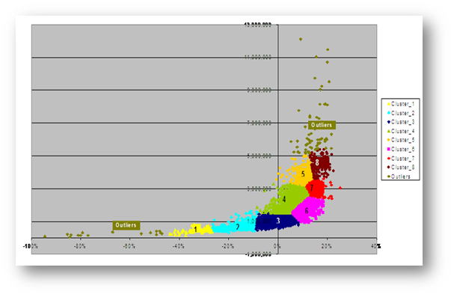

Behavioral Segmentation Solution-Statistical Clustering

**b. Identify your Customer: Targeted Product Marketing**

The key component is to make a personalized offer that suits the particular client’s needs and preferences. Data analytics enables us to create personalized marketing that offers the right product to the right person at the right time on the right device. Data mining is widely used for target selection to identify the potential customers for a new product.

Data scientists utilize the behavioral, demographic, and historical transactional and product ownership data to build propensity models that predict the probability of a customer’s response to a promotion or an offer. Therefore, banks can make an efficient, personalized outreach and improve their relationships with customers.

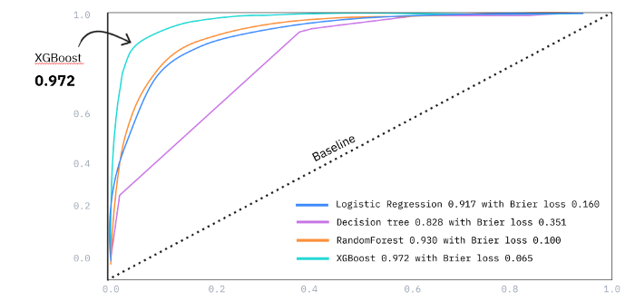

Model Evaluation Comparision for targeted marketing: Propensity Modeling Source: IBM

**c. Entice your Customer: Cross/Up-Sell Modeling**

**Cross-sell or up-sell**models are binary probabilistic algorithms used to identify the most likely customers to respond to an offer or focus on retention activity. Based on existing statistical customer segmentation, propensity models can be developed within homogeneous segments to measure the propensity to respond to a specific product campaign (e.g new credit card campaign)

The model can be applied across specific customer segments and the client can utilize the output together with campaign eligibility criteria to derive new customized campaign strategies. The main advantage of propensity models is that they can generate insight on targeting the more appropriate group of customers and increase product conversion rate (Uplift) relative to baseline random targeting taking into account the campaign and acquisition costs

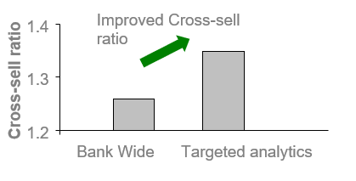

Incremental Revenue from Targeted Cross-Sell Analytics Source: IBM

**d. Satisfy your Customer: Next Best Action**

**Customer Offer Affinity** (also known as Next Best Action) is a form of predictive analytics that helps marketers and their organizations better judge customer product affinity and transactional behavior and guide marketing efforts toward connecting with customers to close a deal.

Next Best Offer is most successful when companies utilize real-time marketing tools. Companies need to know the most up-to-date customer behaviors, needs, and trends to put the “best” in the next best offer. The next best offer is the one “that adds the most value to the customer — as measured by an increase in their overall expected customer lifetime value.”

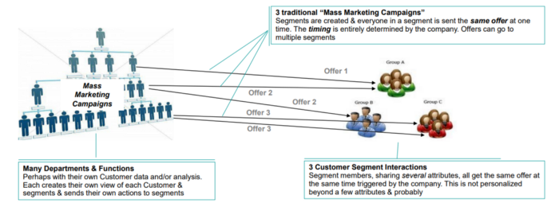

Marketing Campaigns are driven by Next Best Offer Strategy Source: IBM

Banks and financial services providers are challenged to meet and exceed customer expectations in today’s connected and digital world. Financial institutions must focus on engaging with their customers to remain competitive.

**e. Mind your Customer: Customer Retention**

Customer churn, when a customer ends their relationship with a business, is one of the most basic factors in determining the revenue of a business. We need to know which of your customers are loyal and which are at risk of churning, and you need to know the factors that affect these decisions from a customer perspective. Retaining the most profitable clients can be one of the best strategies businesses can have.

While retaining existing customers and thereby increasing their lifetime value is something everyone acknowledges as being important, there is little the banks can do about customer churn when they don’t see it coming in the first place. This is where predicting churn at the right time becomes important, especially when clear customer feedback is absent. Early and accurate churn prediction empowers CRM and customer experience teams to be creative and proactive in their engagement with the customer.

The following SPSS Modeler interface explains how to build a machine learning model and use it to predict whether a customer is at risk of churning. This is a full data science project, and you can use your model findings for prescriptive analysis later or for targeted marketing.

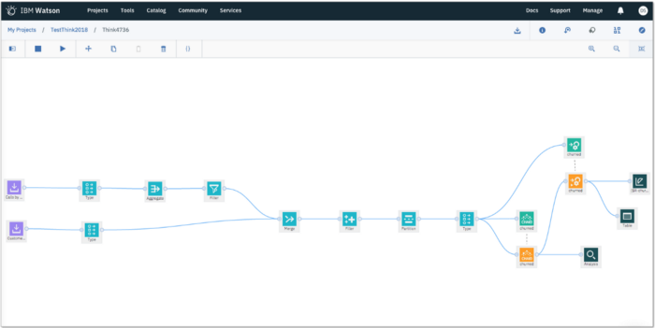

Customer churn prediction model using SPSS Modeler Flow in Watson Studio Source IBM

The key to extracting meaningful predictive insights is in defining the problem statement building blocks as accurately as possible. In the case of customer churn, it starts with defining what is considered a “churn event”.

In general, churn is expressed as a degree of customer inactivity or disengagement, observed over a given time. This manifests within the data in various forms such as the recency of account actions or changes in the account balance. For example, in the case of HNW (High Net-Worth) customers, it is useful to define churn based on the rate of decline of assets over a specified period.

There could be an instance where a customer may be highly active in terms of account operations but has effectively pulled out more than 50% of her assets in the last six months.

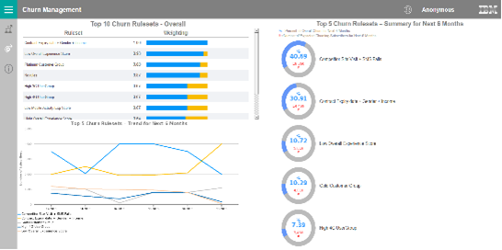

Churn Propensity Dashboard identifying the key model drivers of churn event

It is crucial to determine if churn has to be defined at a product level (customer likely to disengage with a particular product, like discontinuing a credit card) or at the relationship level (customer likely to disengage with the bank itself). When the data is analyzed at a relationship level, you get a better understanding of the customer’s point of view. For example, excessive withdrawal from one’s savings account could be a down payment for a house or funding for college tuition. Such insights into customer life events are very powerful not only to prevent churn but also to cross-sell complementing products which can further strengthen the relationship.

**f. Follow your Customer: Life Event Prediction**

Financial services providers can leverage customer data including demographics, behavior and marketing data, and fine-grained transaction data to predict for example four different customer life events: relocation, Studies, marriage, the birth of a child, new relationship, and end of a relationship.

The results show that the derived customer life event model predicts life events significantly better than random guessing, especially with the combination of fine-grained transactions and aggregated data. Incorporating recency, frequency, and monetary (RFM) value information of well-defined transaction data also significantly improves performance compared with models based on life event prediction & classification.

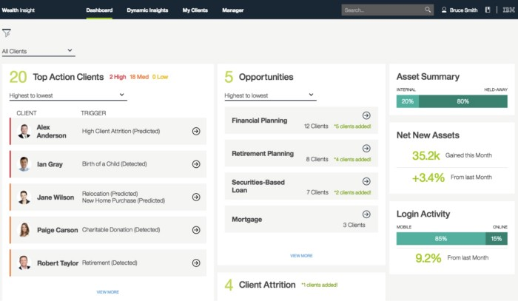

Life Event Predictive Analytics Dashboard Source: IBM Data Science Elite

**g. Value your Customer: Lifetime Value**

**Customer lifetime valu**e (CLTV) is the “discounted value of future profits generated by a customer”, however, the focus of many CLTV models is on the revenue side. The reason for this is that revenue is more difficult to forecast than cost, so a model is more necessary to predict it (and knowing the revenue a customer will generate can inform your spending on that customer). These types of models are often called “customer equity models”.

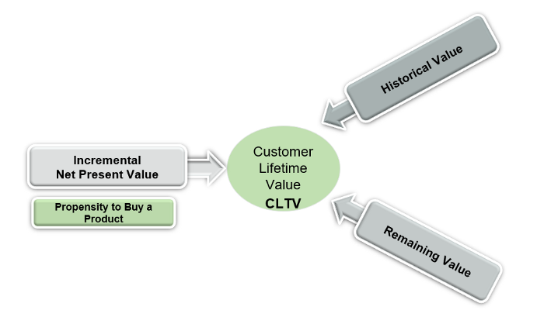

CLTV can be decomposed into the different customer value components

.In this framework, CLTV models are often constraining the same three latent (unobserved) parameters characterizing customers’ behavior:

* **Lifetime:** the period over which a customer is maintaining his or her relationship with the company
* **Purchase rate:**this parameter corresponds to the number of purchases a customer will make over a given period
* **Monetary value:** this part of the model is concerned with assigning a currency unit amount to each future transaction

In the non-contractual setting, these parameters are unobserved. Probabilistic models will help us constrain these parameters at the customer level and make inferences about future purchases and value.

**h. Reward your Customer: Campaign & Loyalty Analytics**

The fact is that analytics has always been a critical part of banks’ loyalty & reward program strategies, banks can build profiling programs for each customer, determine which customers are profitable, understand what methods of motivation are most likely to succeed for each, and then tailor relevant programs uniquely.

Loyalty& reward analytics that are built on “intelligent and responsive technology platforms” give banks a, 360-degree view of their customers, offering insights to enable them to continuously fine-tune those programs to make them more relevant and appealing to specific customers, the article says.

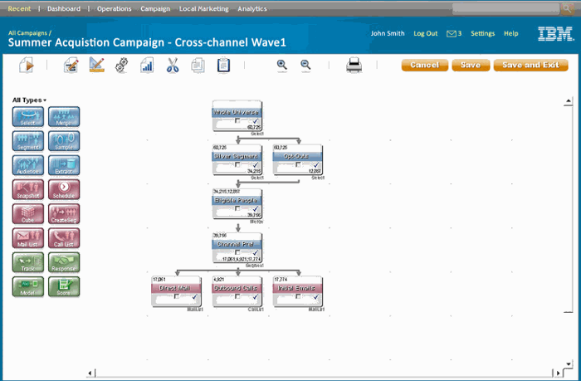

Campaign Analytics taking advantage of cross-selling propensity models in Unica Environment Source: IBM

By using analytics to generate all the necessary insight at the right place and at the right time, banks can create rewards programs that match the diversity and profiles of their customer bases.

However, a bank has to do more than just select the right content and rewards for its customers, it also has to ensure that those customers will engage and make transactions whenever, wherever, and on whatever devices they choose. The key to engagement is regular and tailored customer communication, which can lead to a more successful and profitable relationship.

More precise segmentation, delivering personal offers, and creating targeted email campaigns with advanced marketing analysis. This delivers faster time to market, improved response rates, and better return on marketing spend.

**Watson Customer Analytics for Banking**

**IBM Watson Customer Insight for Banking** uses advanced prebuilt industry-specific analytic models that combine predictive and cognitive capabilities. The solution enables dynamic behavioral segmentation to uncover actionable customer insights allowing banks to create personalized sales offerings and marketing campaigns. The solution provides intuitive user interfaces and role-specific dashboards specifically designed for line of business users.



Watson Customer Insights enables banks to generate better insight into customer needs through customer analytics Source: IBM

1. Dynamic segmentation based on customer behaviors
2. Identify propensity to buy or cross/up-sell by determining the level of engagement for each customer based on their behaviors.
3. Anticipate customer life events: predict potential life events for your customers to provide a proactive, personalized experience
4. Improve the ability to retain your most profitable customers by predicting attrition risks.
5. Identify highly profitable customers for retention, marketing, and new product development.

**IBM Acoustic Analytics (formerly Watson CX Analytics)** helps you make smarter, faster marketing and customer experience decisions based on insights into customers across touchpoints. Acoustic Journey Analytics lets you visualize the journeys that your customers take as they interact with your brand across devices, channels, and touchpoints.

Journey Analytics provides insights at every level, from company-wide aggregates down to a single user’s experience. It helps you to understand the customer journey as a whole, without having to use separate tools to examine channels and session data. The knowledge that you gain from your analysis can help you to improve business outcomes, drive conversions, and deliver consistent and satisfying customer experiences.

The role-based dashboard in Journey Analytics makes it easy to visually identify important trends and then drill deeper to uncover customer behavior causes. You can also identify where customers struggle, and then replay individual customer sessions to see the exact source of the problem.

